BREAKFAST CHATTER
Weekly Bulletin of Rotary Club of Kathmandu Mid-Town
District 3290 Volume No. 15/22 for #764 December 17, 2004
www.rotarymidtown.org.np
DECEMBER IS ELECTION OF NEW BOARD MONTH
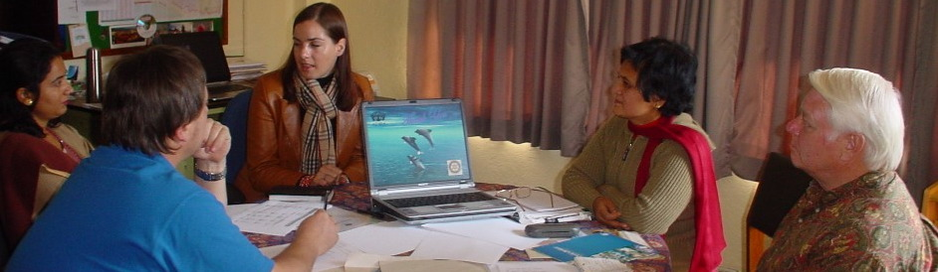
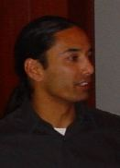
SUNSHINE ANNOUNCEMENT FOR THE WEEK OF 17 & 24 DECEMBER 2004; A Happy Holiday Birthday to Manju, spouse of Rtn Navyo…!!!!!!!!!!!!!!!!!!!!!!!!!!!!!!!!!!!!!!!!!!!!!!!!!!!!!!!!!!
Rtn Arun, Peter & Navyo (spouse of Manju) attend ADRA meeting Ravi Karmacharya spoke on the challenges of building a 21st Century software enterprise in Nepal

*********** MEETING ACTIVITIES:
DATE | ACTIVITY | SUBJECT
17 DEC | CLUB ASSEMBLY | Thoughts of Rtn Luke & Reports from Directors
18 DEC | SKY CYCLING | RIDE THE WIREBRIDGE & WIREROAD
24 DEC | HOLIDAY | HAPPY CHRISTMAS HOLIDAY NO MEETINGÍ
31 DEC | Fr. Bill Robins | to be announced
7 JAN | Subarna Joshi | Community Participation in Local Area Development
14 JAN | ADRA | On partnership activities?
JAN | Health Camps | Naubise & Tistung with ADRA/Hartmut
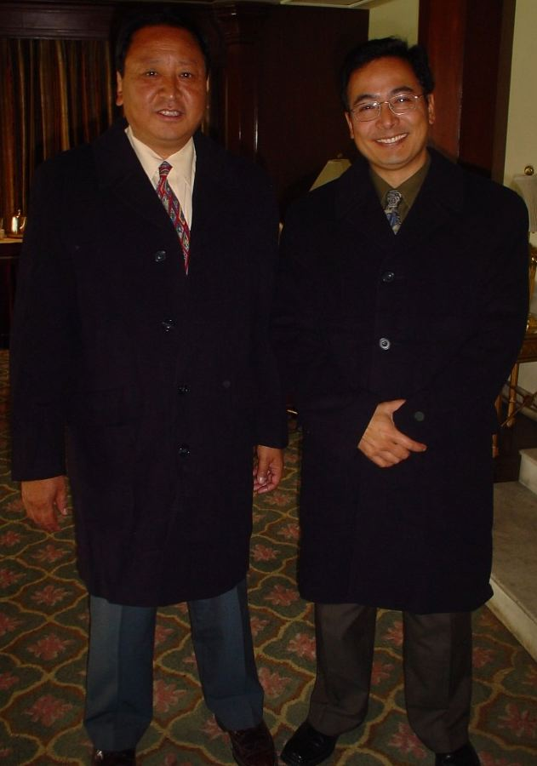
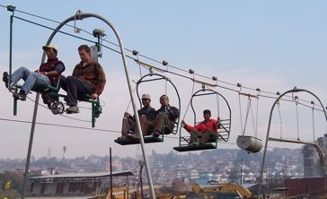
**************** NEWS:, Rotarian Luke and spouse Marian are soon returning to California. Farewell thoughts this Friday *** Almost-Matrix overcoats (see models) ← are available at Rs 2,500 – if the overcoat fits, you need to wear it? *** Saturday is the sky cycling opportunity – 10AM to 2PM. Dress as if for a short hike. *** ****************
World-class models
LUKE SUNDE: NEPAL & CALIFORNIA—HIS THOUGHTS; ALSO CLUB ASSEMBLY. **************** Please join us! YIR…David

